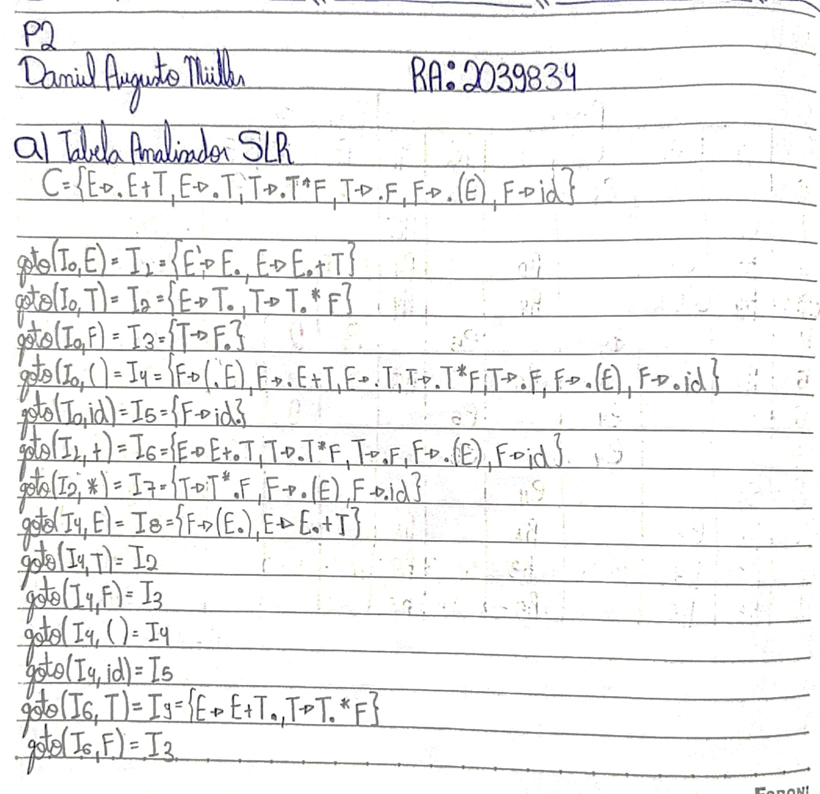

**Tabelas da letra B), C) e D) estão digitalizadas no final do arquivo**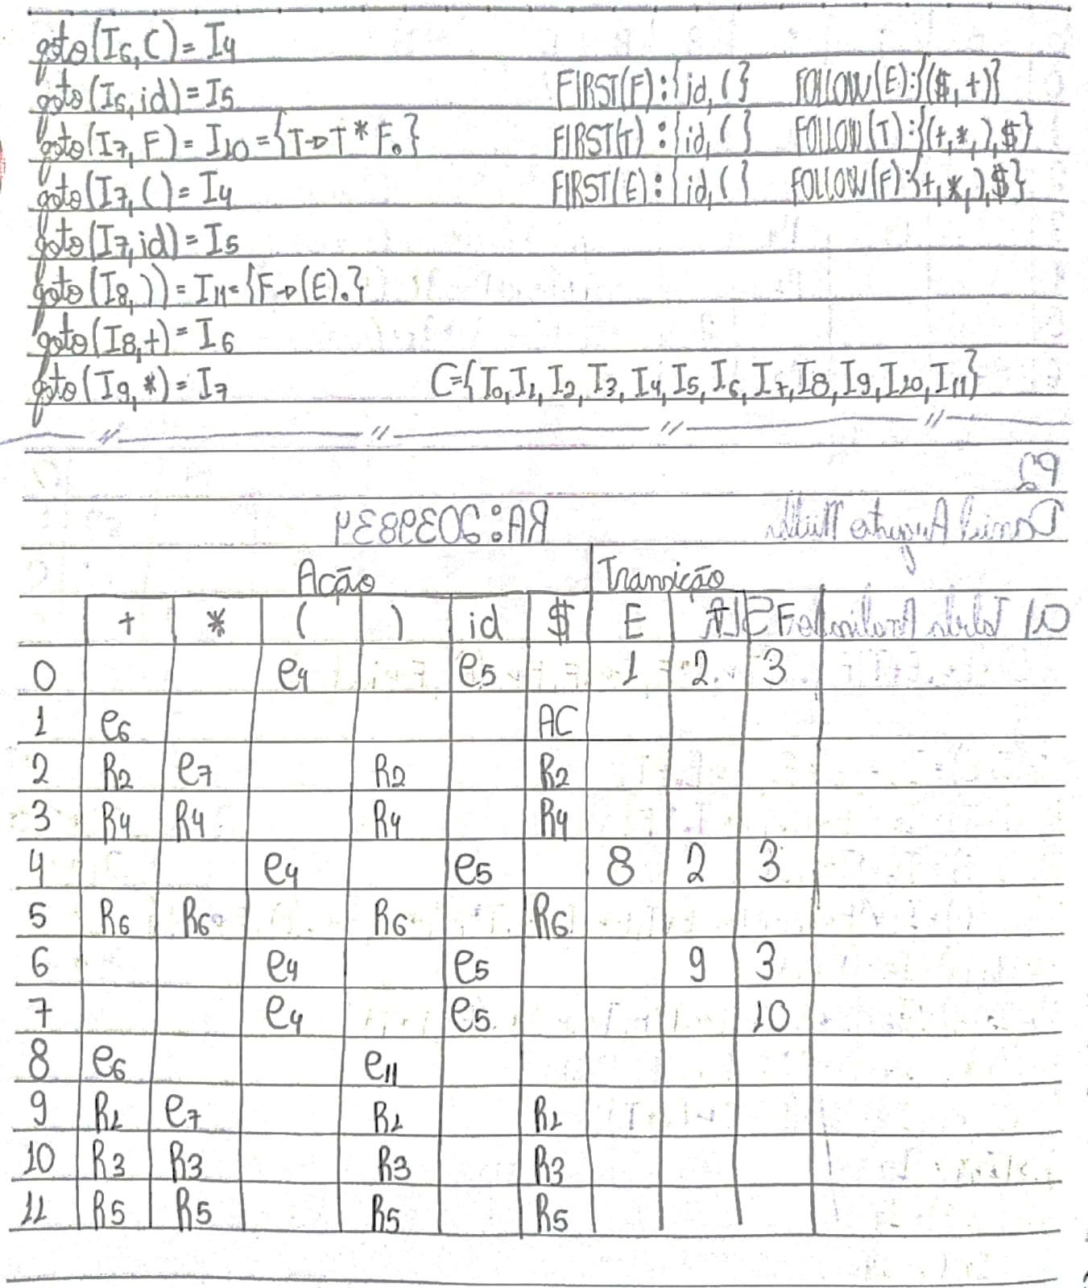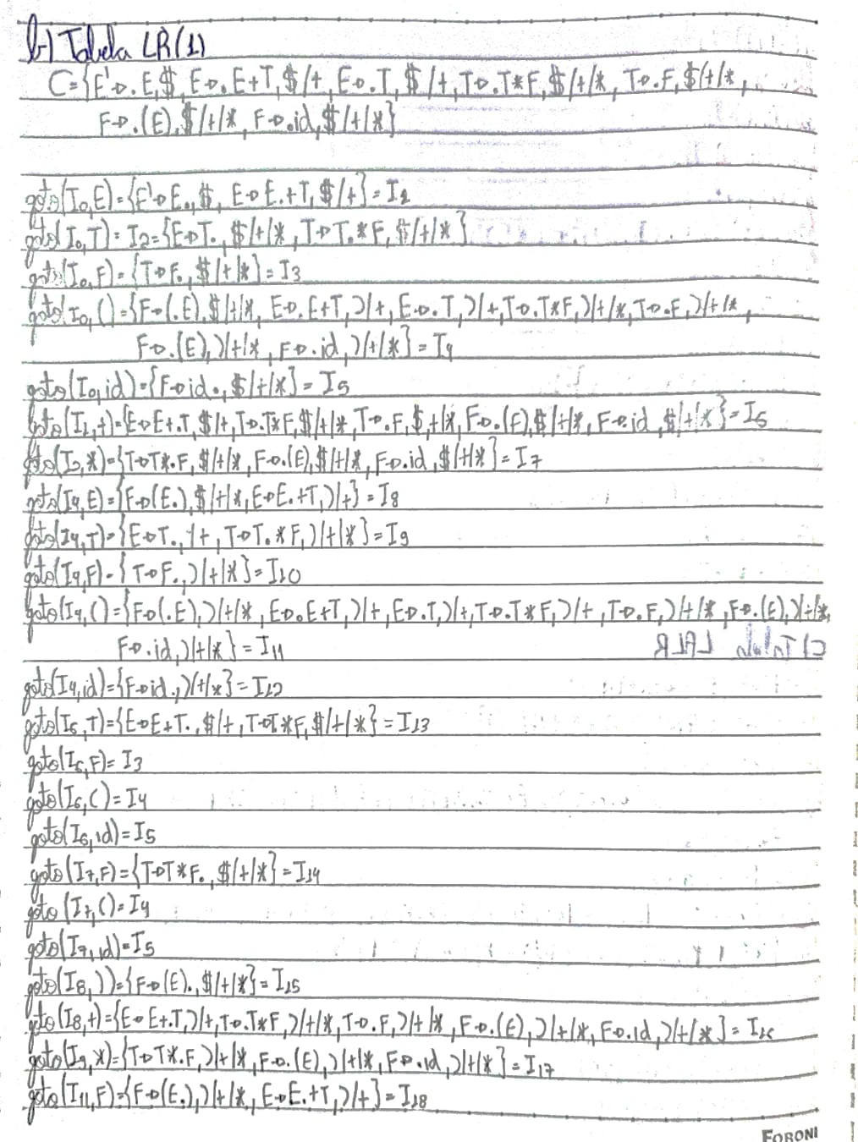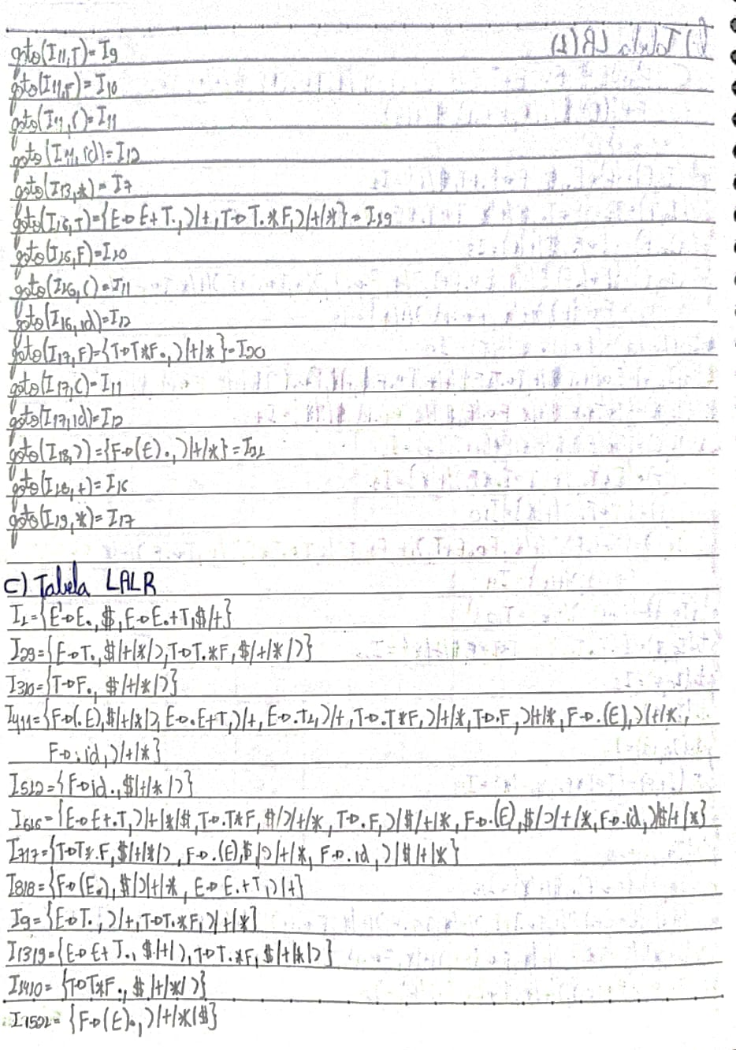

**B) TABELA LR**

|  |  |  |  |  |  |  |  |  |  |
| --- | --- | --- | --- | --- | --- | --- | --- | --- | --- |
|  | **AÇÃO** | | | | | | **TRANSIÇÃO** | | |
|  | **+** | **\*** | **(** | **)** | **id** | **$** | **E** | **T** | **F** |
| **0** |  |  | E4 |  | E5 |  | 1 | 2 | 3 |
| **1** | E6 |  |  |  |  | AC |  |  |  |
| **2** | R2 | E7 |  | R2 |  | R2 |  |  |  |
| **3** | R4 | R4 |  | R2 |  | R4 |  |  |  |
| **4** |  |  | E11 |  | E12 |  | 8 | 9 | 10 |
| **5** | R6 | R6 |  | R6 |  | R6 |  |  |  |
| **6** |  |  | E4 |  | E5 |  |  | 13 | 3 |
| **7** |  |  | E4 |  | E5 |  |  |  | 14 |
| **8** | E16 |  | E15 |  |  |  |  |  |  |
| **9** | R2 | E17 |  | R2 |  | R2 |  |  |  |
| **10** | R4 | R4 |  | R4 |  | R4 |  |  |  |
| **11** |  |  | E11 |  | E12 |  | 18 | 9 | 10 |
| **12** | R6 | R6 |  | R6 |  | R6 |  |  |  |
| **13** | R1 | E7 | R1 |  |  | R1 |  |  |  |
| **14** | R3 | R3 |  | R3 |  | R3 |  |  |  |
| **15** | R5 | R5 |  | R5 |  | R5 |  |  |  |
| **16** |  |  | E11 |  | E12 |  |  | 19 | 10 |
| **17** |  |  | E11 |  | E12 |  |  |  | 20 |
| **18** | E16 |  |  | E21 |  |  |  |  |  |
| **19** | R1 | E17 | R1 |  |  | R1 |  |  |  |
| **20** | R3 | R3 |  | R3 |  | R3 |  |  |  |
| **21** | R5 | R5 |  | R5 |  | R5 |  |  |  |

**C) TABELA LALR**

|  |  |  |  |  |  |  |  |  |  |
| --- | --- | --- | --- | --- | --- | --- | --- | --- | --- |
|  | **AÇÃO** | | | | | | **TRANSIÇÃO** | | |
|  | **+** | **\*** | **(** | **)** | **id** | **$** | **E** | **T** | **F** |
| **0** |  |  | E4 |  | E5 |  | 1 | 2 | 3 |
| **1** | E616 |  |  |  |  | AC |  |  |  |
| **9** | R2 | E717 |  | R2 |  | R2 |  |  |  |
| **29** | R2 | E717 |  | R2 |  | R4 |  |  |  |
| **310** | R4 | R4 |  | R4 |  | R4 |  |  |  |
| **411** |  |  | E11 |  | E512 |  | 8 | 9 | 10 |
| **512** | R6 | R6 |  | R6 |  | R6 |  |  |  |
| **616** |  |  | E411 |  | E512 |  |  | 13 | 3 |
| **717** |  |  | E411 |  | E512 |  |  |  | 14 |
| **818** | E16 |  |  | E15 |  |  |  |  |  |
| **1319** | R1 | E717 | R1 |  |  |  | R1 |  |  |
| **1420** | R3 | R3 |  | R3 |  |  | R3 |  |  |
| **1521** | R5 | R5 |  | R5 |  |  | R5 |  |  |

**D) Palavra: id * id**

**Analisador SLR**

|  |  |  |
| --- | --- | --- |
| **PILHA** | **ENTRADA** | **AÇÃO** |
| 0 | id*id $ | E5 |
| 0 id 5 | *id $ | R6 |
| 0 F 3 | *id $ | R4 |
| 0 F 2 | *id $ | E7 |
| 0 F 2 id 7 | id $ | E5 |
| 0 F 2 id 7 id 5 | $ | R6 |
| 0 F 2 id 7 F 10 | $ | R3 |
| 0 T 2 | $ | R2 |
| 0 E 1 | $ | Aceito |